**Uploading Files to AWS S3 Bucket using Boto**

1. Check if python is installed in your computer. If python is not installed in the following instructions then follow the instructions in the link

<https://www.ics.uci.edu/~pattis/common/handouts/pythoneclipsejava/python.html>

Append your installation path and PIP path

(**C:\Users\bmudaliyar\AppData\Local\Programs\Python\Python37-32)**

**(C:\Users\bmudaliyar\AppData\Local\Programs\Python\Python37-32\Scripts)**

To the PATH variable in System variables. So that you can run python from anywhere in command line. Control panel🡪 System🡪Advanced Settings🡪Environment Variables🡪Edit path

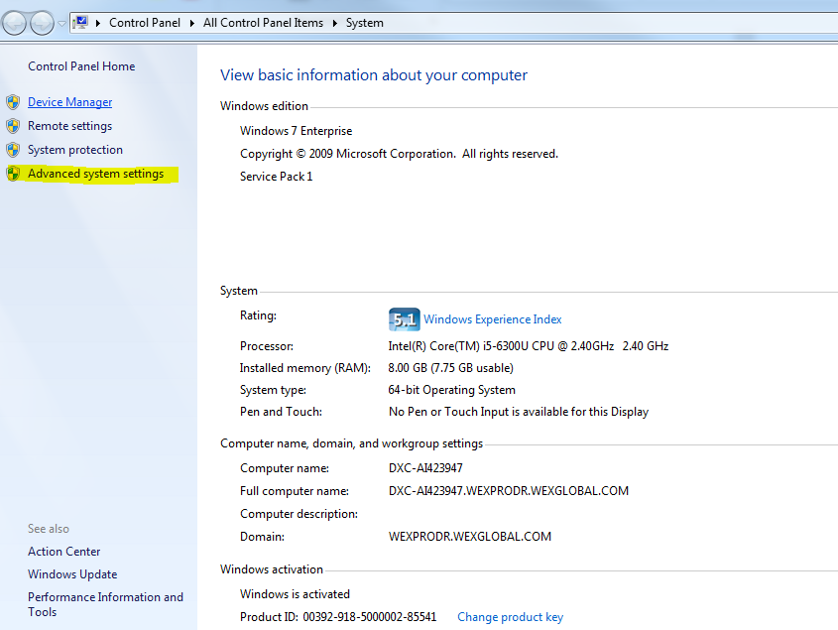

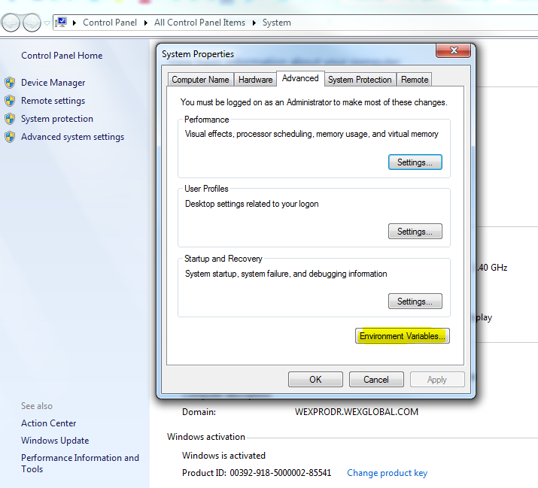

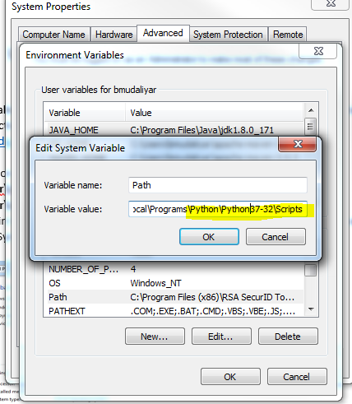

After adding both the paths you can run pip command and python command conveniently from command line.

1. After installing python, we will install AWS Command Line Interface (AWSCLI) by executing command ”**pip install awscli**” from command line.

The AWS Command Line Interface (AWS CLI) is a unified tool that provides a consistent interface for interacting with all parts of AWS. AWS CLI commands for different services are covered in the accompanying user guide, including descriptions, syntax, and usage examples.

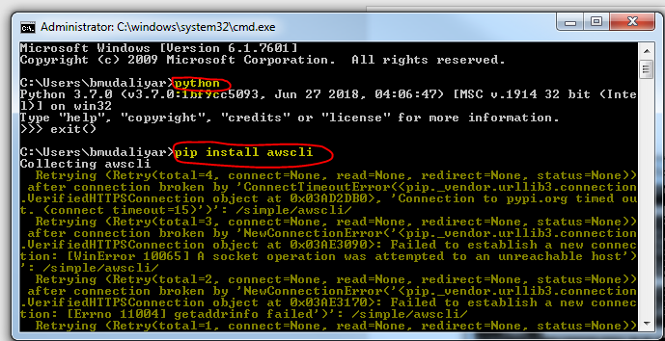

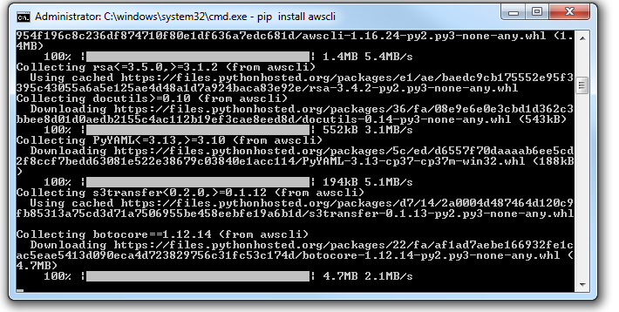

1. **Install Boto3**

Boto3 is the Amazon Web Services (AWS) Software Development Kit (SDK) for Python, which allows Python developers to write software that makes use of services like Amazon S3 and Amazon EC2.

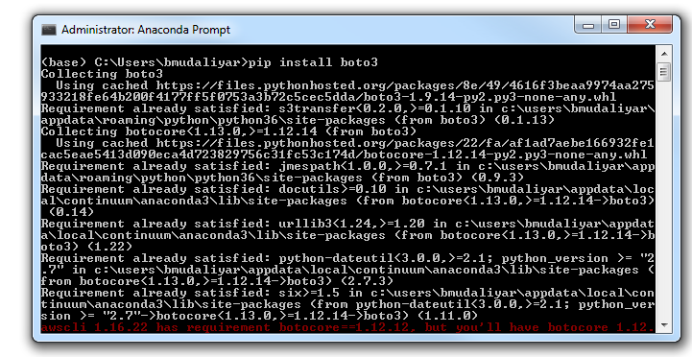

1. **Open the below .py file in Pycharm /Jupyter notebook(by converting the file to .ipynb format) and edit the code by giving your credentials:**



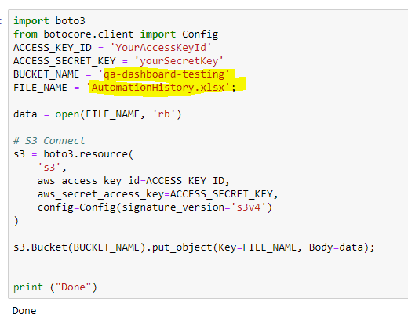

1. **Once the .py file is ready, we will execute the file from command line:**

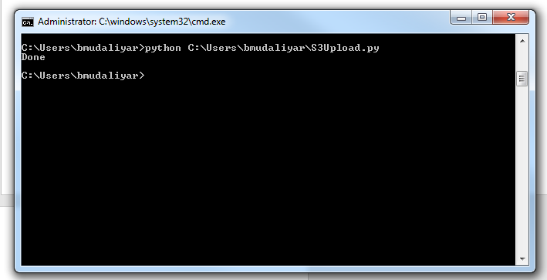

**Before executing the .py file:**

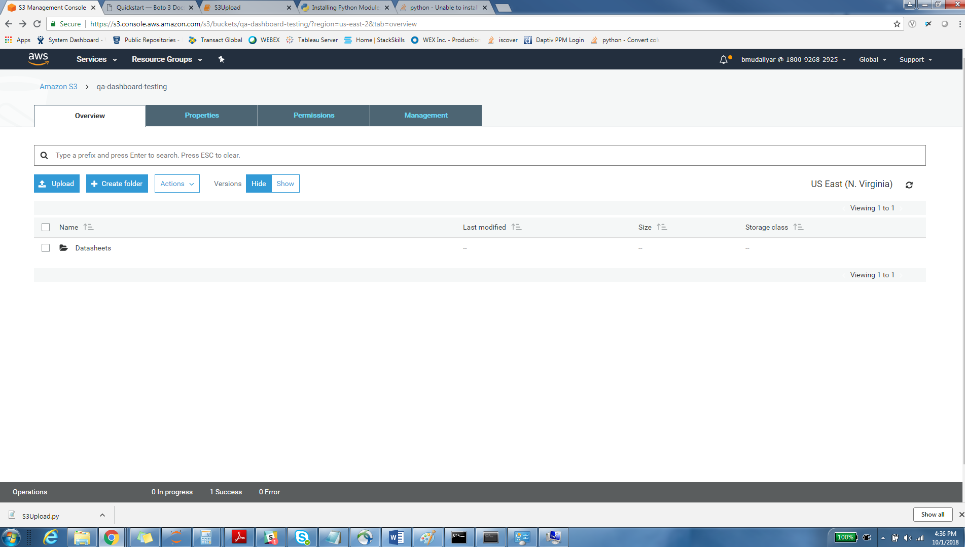

**After executing the .py file:**

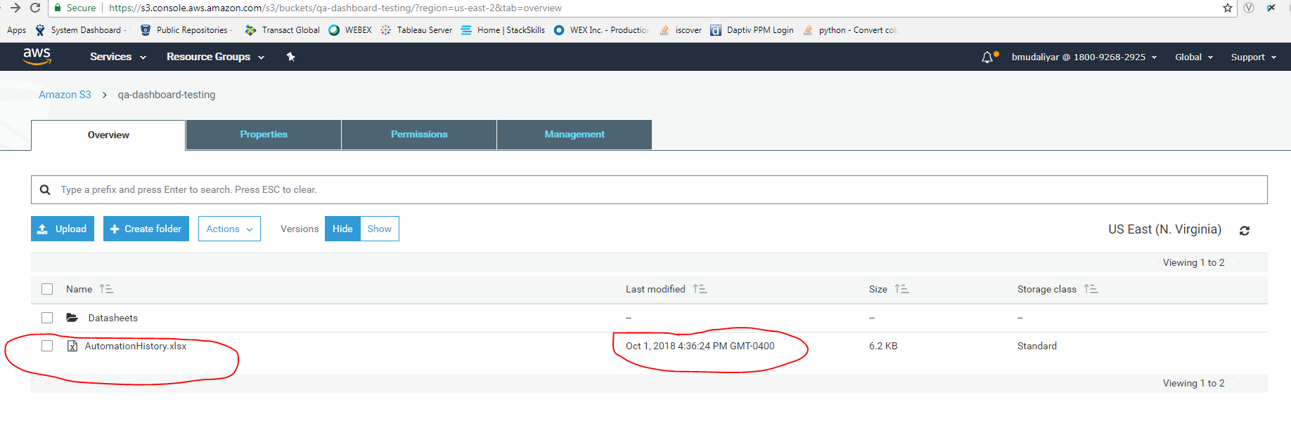

We can clearly see that the file has been uploaded in the S3 Bucket. We can run the .py file in regular intervals using window tasks scheduler.